Once the user is logged in, he/she is presented with a menu with five options (see Fig 2.0). Option N is to start a new graduation planner. Option M allows the user to modify an existing planner. Option V allows the user to view their current planner. Option P allows the user to print the planner out. The user is also given the option to exit the program with option Q.

The following screens follow from Fig 1.0:

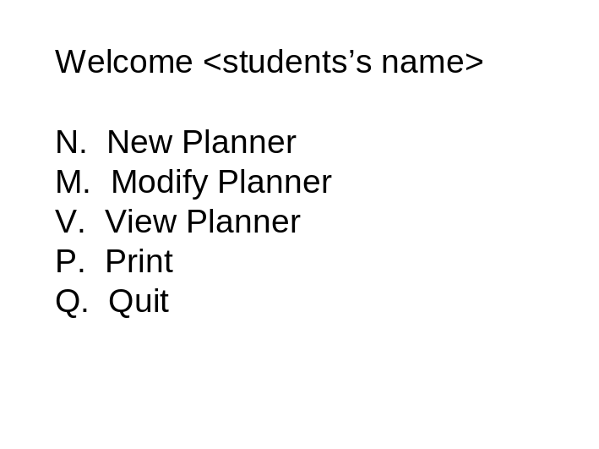
Fig 2.0
Student enters in one of the letters in a prompt.

4

New Graduation Plan Dialog
If option N is selected the user is given the option to start a new planner (see Fig 3.0 below). User is asked to enter a beginning semester, pick major and confirm information.
If the user chooses Y it returns to Fig 2.0 if N is entered Fig 3.0 s refreshed.

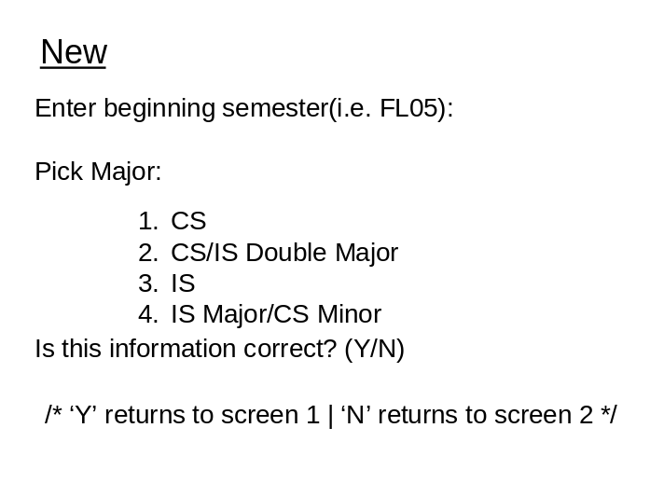
Fig 3.0

5
Modify Graduation Plan Dialog
If option M is selected the user is given the option to modify an existing planner (see Fig 4.0 below). User is presented with a menu of 3 options. Option A lets user add a semester. Option M allows student to modify a semester and option B takes user back to Fig 2.0

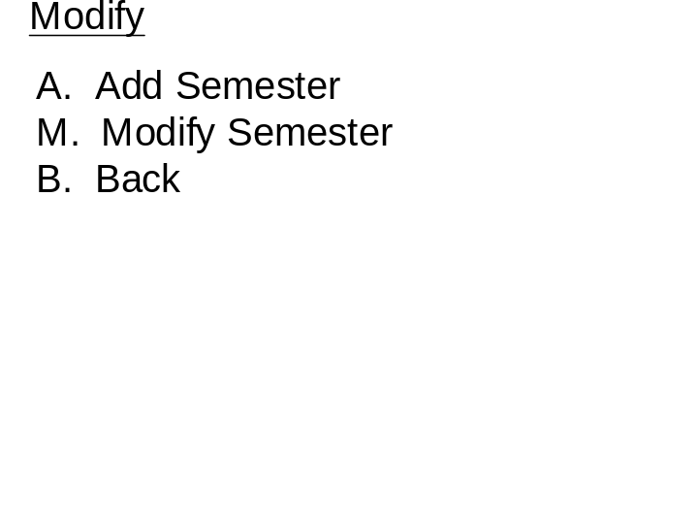
Fig 4.0
The student is prompted for a selection and taken to the appropriate screen.

6
Add Semester Dialog
If user chooses option A, the user is prompted to enter a semester (formatted) as shown in Fig 4.1 below. The student is then prompted for enter a year and this screen returns to Fig 4.0

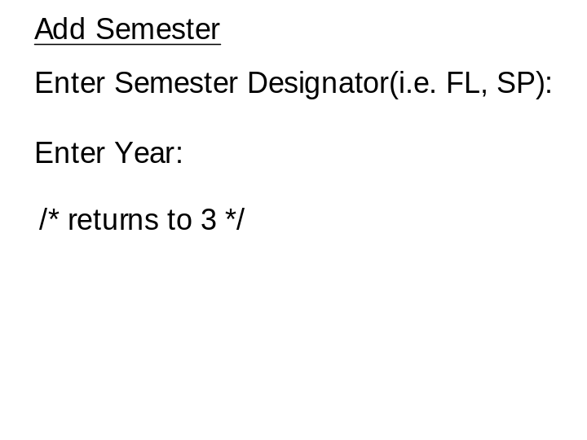
Fig 4.1

7
Modify Semester Dialog
If user chooses option M, the user is presented with another menu as shown in Fig 4.2 below. Option A lets user add a course, option D lets user deletes a course and option B takes user back to Fig 4.0

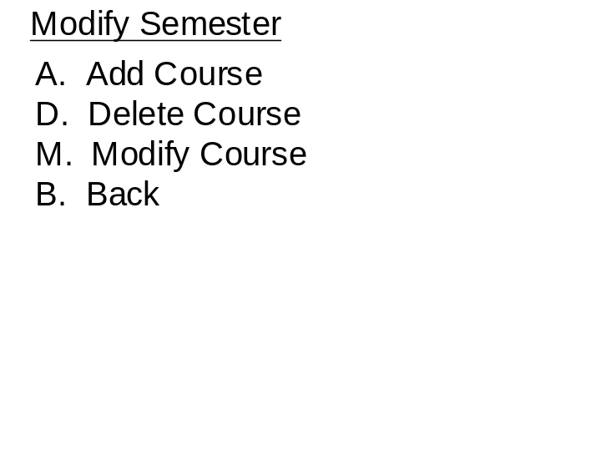
Fig 4.2

The student is prompted for a selection.

8
Add Course Dialog
If user enters option A, the student is prompted to enter the course designator (see Fig 4.2.1). The student is prompted to enter the course number and then the number of credits. This screen will return certain information pending the validity of the input. Also this prompt will accept SS or AH as input instead of a real course designator.
When all data is entered screen will return to Fig 4.2

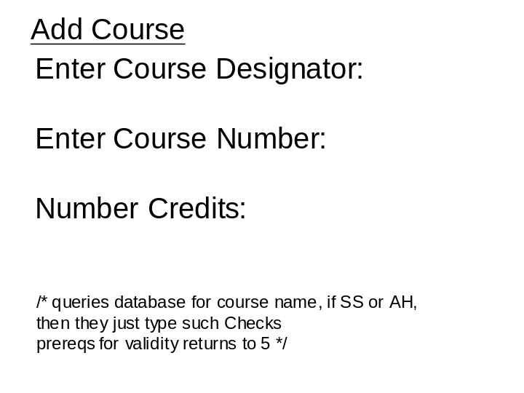
Fig 4.2.1

9
Delete Course Dialog
If option D is selected, the program outputs a menu of courses in record (see Fig 4.2.2). The student is prompted which to delete, and is prompted to confirm. After confirmation, the screen returns to Fig 4.2

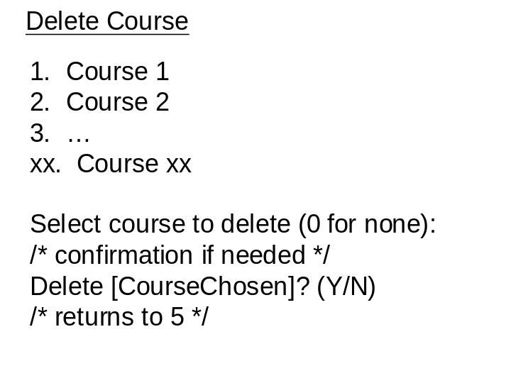
Fig 4.2.2

10
Modify Course Dialog
If option M is selected, the student is prompted to enter a new grade and then for comments (see Fig 4.2.3). The student is prompted to confirm changes, then the screen returns to Fig 4.2.

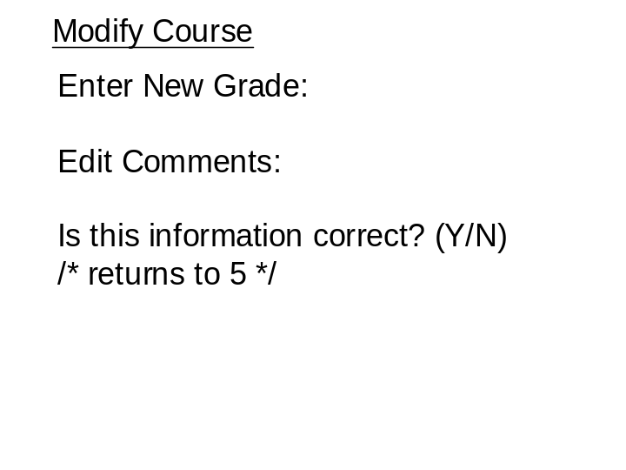
Fig 4.2.3

11
Print Dialog
From Fig 2.0, if user chooses option P, a menu is presented as in Fig 5.0 below. Option E lets user print entire planner, option R prints a range of semesters and option B lets user go back to Fig 2.0

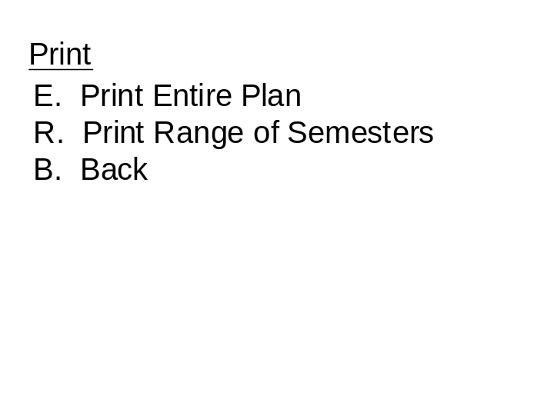
Fig 5.0

The student is prompted for a selection.

12
Print Range of Semesters Dialog
User chooses option R and Fig 5.1 is displayed prompting user to enter start and end. Then after printing returns to Fig 5.0

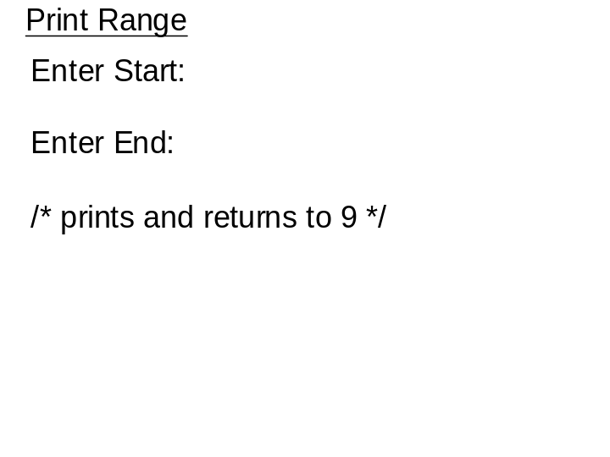
Fig 5.1

The student is prompted for a starting and ending semester to print this range.

13
Print Entire Plan Dialog
User chooses option R and Fig 5.2 is displayed and entire plan is printed. After printing returns to Fig 5.0

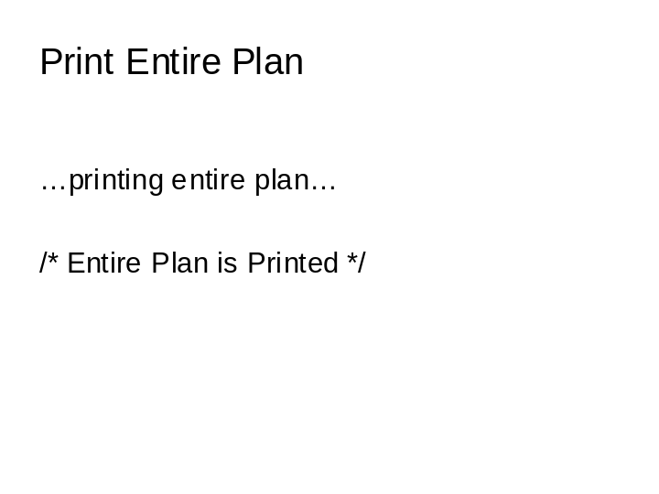
Fig 5.2

This just prints the entire plan, and there is no input for the user.

14
View Dialog
From Fig 2.0 if user chooses option V, a menu with three options is displayed (see Fig 6.0). If option R is chosen, view remaining graduation requirements, option S view selected semester. Option B, back to Fig 2.0

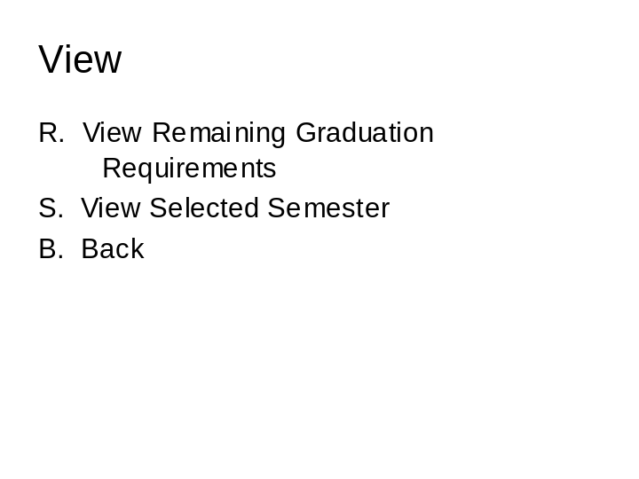
Fig 6.0

15
View Remaining Graduation Requirements Dialog
User chooses option R and the following screen is displayed (see Fig. 6.1). When user is done viewing user enters D to return to Fig.6.0

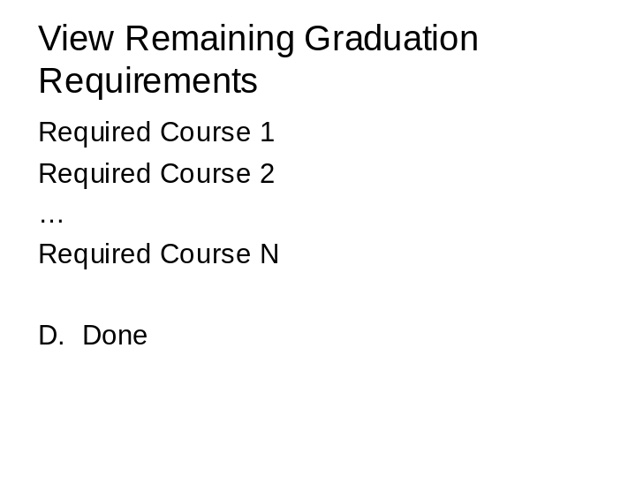
Fig 6.1

16
Select Semester Dialog
User chooses option S and the following screen is displayed (see Fig. 6.2). A menu of semesters is provided and the user must choose which semester he/she wants to see by selecting a number otherwise the user enters a 0 to return to Fig.6.0

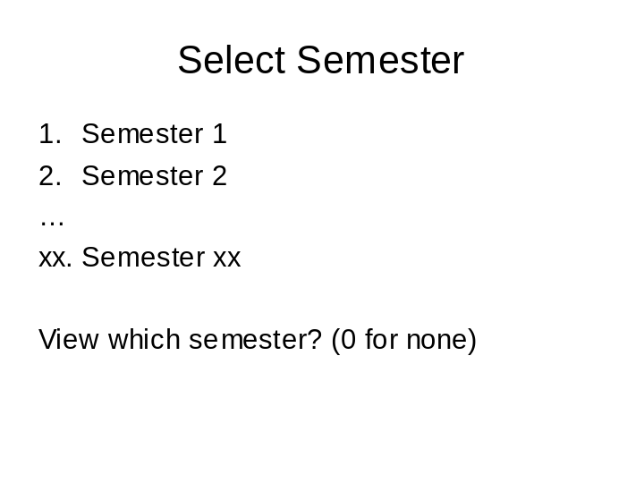
Fig 6.2

17
Select Course Dialog
User chooses an option, that is one of the numbers displayed in 6.2, and the following screen is displayed (see Fig. 6.2.1). A menu of courses is provided and the user must choose which course he/she wants to see by selecting a number otherwise the user enters a 0 to return to Fig.6.2

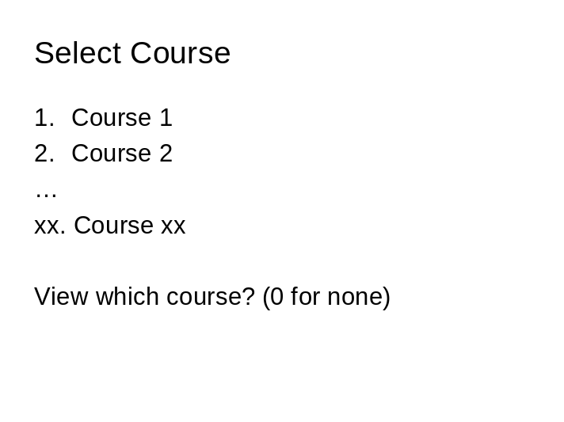
Fig 6.2.1

18
View Course Dialog
User chooses an option, that is one of the numbers displayed in 6.2.1, and the following screen is displayed (see Fig. 6.2.2). The course description is displayed and the user enters a D to return to Fig.6.2.1

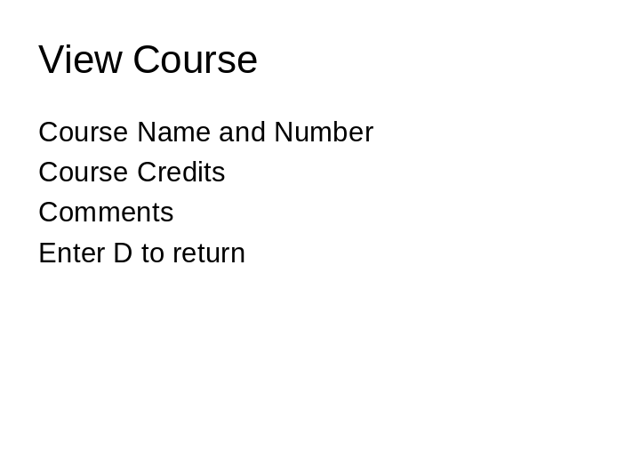
Fig 6.2.2

19

